**Testing Data/Guide**

To show tested values, I shall run through several scenarios rather than have a specific set of values. Most of the fields clear once submitted to show the user they were accepted, so screen shots are difficult with so many options.

First, entering a non-integer will produce a very noticeable notification to the user and will not ‘lock-in’ as the button would if an integer was entered.

Once an integer is entered the first time the ‘to begin’ banner disappears. In this case since the ‘must be an integer’ label is in place; it too will be removed upon successful ‘lock-in’ of the user weight

After this, the user can enter in whatever order they like before entering the grand total.

**EXERCISE ENTRY**

If nothing is entered the total remains unaltered. (Tested, difficult to screenshot)

If a non-integer is entered the field clears and the total remains unaltered. (Tested, difficult to screenshot)

If a valid entry is entered, weight is locked in, and exercise is selected –

the output will be calculated and presented at the top, and the field will be cleared

Repeated entries will calculate the proper result.

The Total result can be cleared – the accumulator is also reset to assure proper output (this was a bug I had to track down and fix. I was missing this bug because while testing I did not use more than one entry, but found it in my final checks)

**Food Entry**

Any non-integer or negative value will be converted to 0 and not included in the total. The other fields will then operate as normal. The total is updated at the top, and the fields are cleared

If ‘Press again to clear” is pressed, it clears the total at the top

The Directions button works and its close window button and function work properly

With 200 User weight – 45 minutes of Running, 1 hour of walking, and 25 minutes of bicycling added to the top

On the food side, A large breakfast leads to a light lunch – followed by a heavy dinner and small snack total

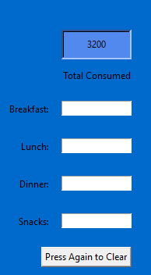

Finally, the totals of the two totals are added upon press of the ‘Calculate total’ button

A bug I encountered here that required fixing was due to float rounding the digit would often be off by one. Resolved.